Question 4

**SELECT** *\** **FROM** BILLINGADDRESS **FETCH FIRST** 10 **ROW ONLY**;

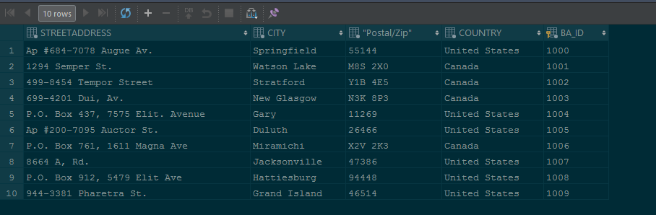

**SELECT** *\** **FROM** CARTDETAILS **FETCH FIRST** 10 **ROW ONLY**;

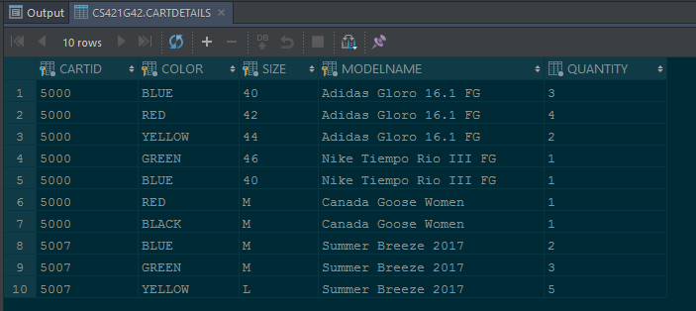

**SELECT** *\** **FROM** ClothingCategory **FETCH FIRST** 10 **ROW ONLY**;

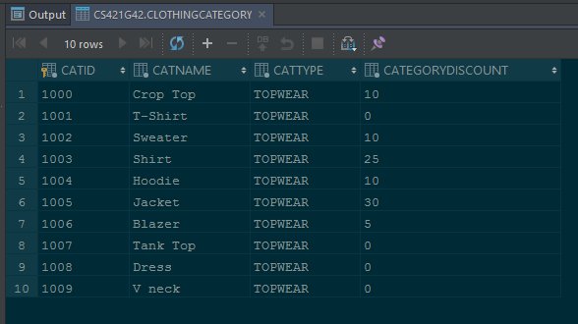

**SELECT** *\** **FROM** CLOTHINGUNIT **FETCH FIRST** 10 **ROW ONLY**;

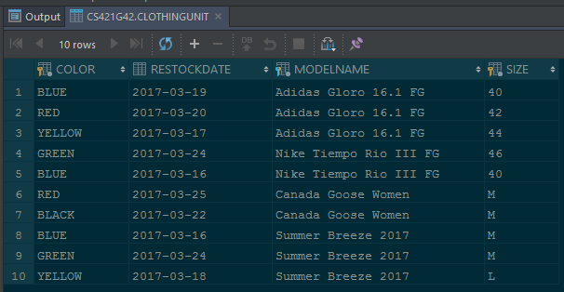

**SELECT** *\** **FROM** CUSTOMER **FETCH FIRST** 10 **ROW ONLY**;

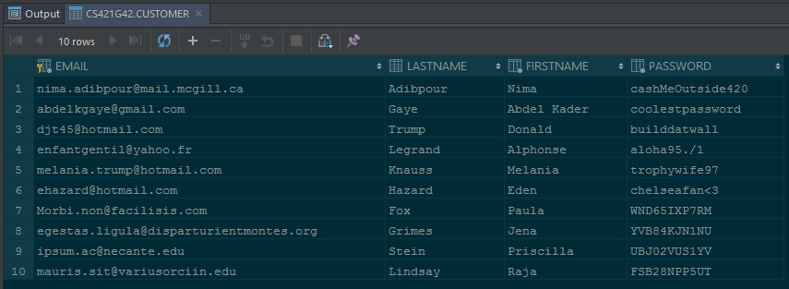

**SELECT** *\** **FROM** EMPLOYEE **FETCH FIRST** 10 **ROW ONLY**;

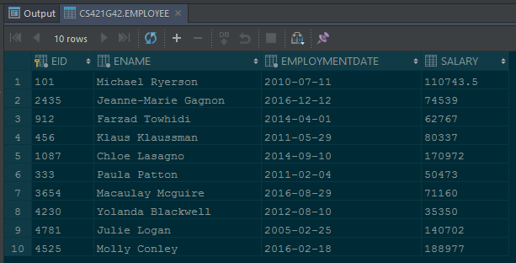

**SELECT** *\** **FROM ORDER FETCH FIRST** 10 **ROW ONLY**;

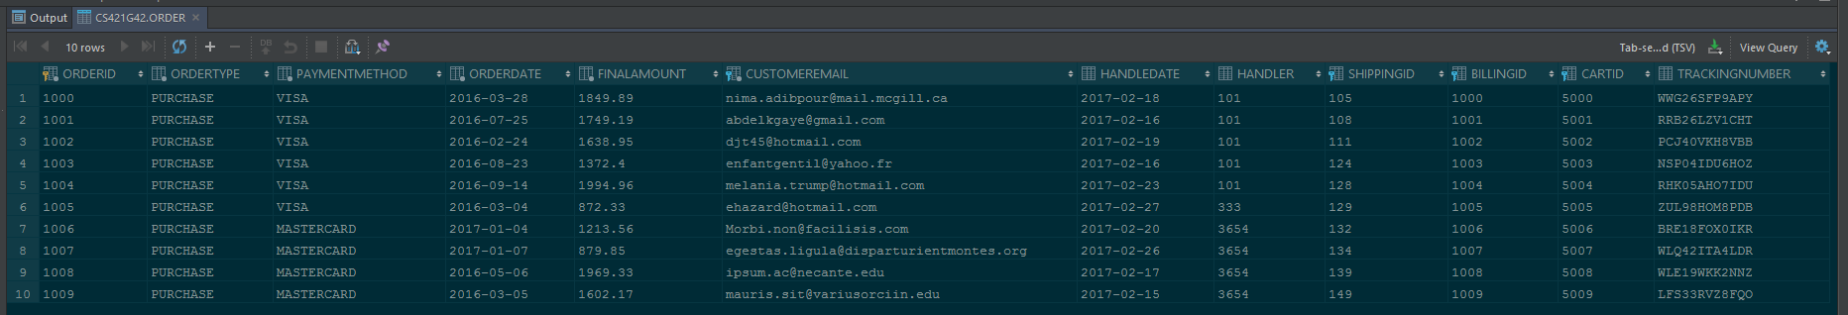

**SELECT** *\** **FROM** SHIPPINGADDRESS **FETCH FIRST** 10 **ROW ONLY**;

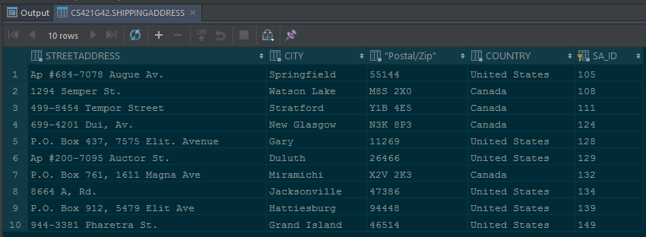

**SELECT** *\** **FROM** SHOPPINGCART **FETCH FIRST** 10 **ROW ONLY**;

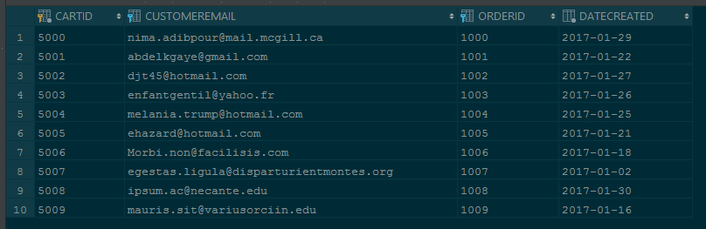

**SELECT** *\** **FROM** UNITSTOCKING **FETCH FIRST** 10 **ROW ONLY**;

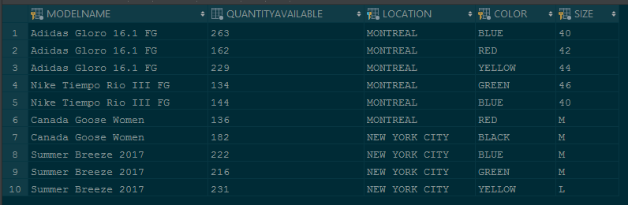

**SELECT** *\** **FROM** WAREHOUSE **FETCH FIRST** 10 **ROW ONLY**;

